**Inge, W.R. (William Ralph** **) (1860-1954)**

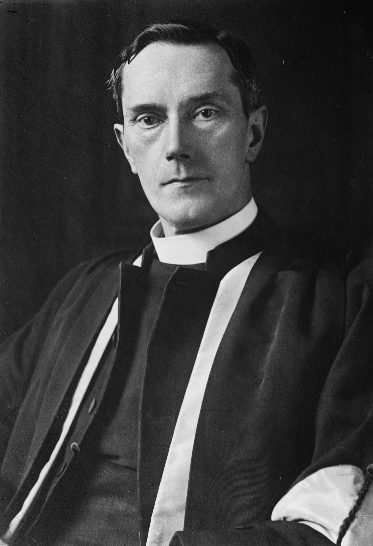William Ralph Inge, an Anglican churchman and scholar, was the recipient of many institutional honours. Beginning his professional academic career, and also entering the Church, at Oxford (1888-1905), he went on to become the Lady Margaret's Professor of Divinity at Cambridge (1907-1911); Gifford Lecturer (1917-1918); and Dean of St Paul’s (1911-1934).

For literary modernists, he was chiefly known under two guises. He was the ‘Gloomy Dean’ of the *Evening Standard*, where he wrote a regular column filled with deeply pessimistic cultural criticism (1921-1946). Inge’s journalistic platform, alongside his ecclesiastical appointment, made him a well-known figure and he even featured on the cover of *Time* on 24 November 1924.

He was also one of the leading, and most widely-read, Anglophone scholars of mysticism at the turn of the twentieth century, alongside William James, Evelyn Underhill and Rufus Jones. Inge not only analysed the mystical tradition but also published an important anthology of German mystical writings that made Meister Eckhart, for instance, available, to readers, in English. His understanding of mysticism, as the title of his Gifford Lectures, *The* *Philosophy of Plotinus,* implies, was moulded by the contours of the neo-Platonic influence upon Christianity. Yet, his explorations of mysticism were not limited to, or confined by, historical scholarship. Inge was a theological liberal, associated with the Anglican theological modernist journal *The Modern Churchman*, and he considered it important that congregations engage with the Christian mystical tradition; the Church needed, in his view, to afford the faithful a more immediate form of religious encounter than had been available to the masses in the past.

Inge’s Bampton lectures entitled *Christian Mysticism* were published in 1899 and served as important source texts for both T.S. Eliot and Samuel Beckett. Beckett read Inge in 1930-1931 during the composition of *Dream of Fair to Middling Women* and Eliot made notes on the volume as a graduate student. Eliot also encountered Inge’s *Studies of English Mystics* during the same period; the volume served as an introduction to the fourteenth- and fifteenth-century English mystics who would become important to Eliot after his baptism and, notably, during the composition of ‘Little Gidding’.

**Selected Works**

*Christian Mysticism* (London: Methuen, 1899).

<http://www.gutenberg.org/ebooks/14596>

*Light, Life and Love: Selections from the German Mystics of the Middle Ages* (London: Methuen, 1904).

<https://archive.org/details/lightlifeandlov00ingegoog>

*Studies of English Mystics* (London: John Murry, 1906).

<https://archive.org/details/cu31924029351453>

*The Philosophy of Plotinus*. 2 Vols. (London: Longmans, 1918).

<https://archive.org/details/philosophyofplot01inge>

<https://archive.org/details/philosophyofplot032854mbp>

<http://www.giffordlectures.org/lectures/philosophy-plotinus-vol-1>

<http://www.giffordlectures.org/lectures/philosophy-plotinus-vol-2>

**Further Reading**

Gordon, Lyndall (1977). *Eliot’s Early Years*. Oxford. Oxford University Press.

Helm, Robert M. (1962). *The Gloomy Dean: The Thought of William Ralph Inge*. Winston-Salem. John F. Blair.

Tonning, Erik (2010). ‘“Nor by the eye of flesh nor by the other”: Fleshly, Creative and Mystical Vision in Late Beckett’. *Samuel Beckett Today / Aujourd'hui* 22: 223-39.

**Further Links**

Gifford Lecturer Biography (<http://www.giffordlectures.org/lecturers/william-ralph-inge>)

Lady Margaret's Professors Page (<http://www.divinity.cam.ac.uk/library/historyoffaculty/ladymargaret#section-8>)

Project Canterbury Page (<http://anglicanhistory.org/england/wringe/>)

Jamie Callison, University of Bergen & University of Northampton